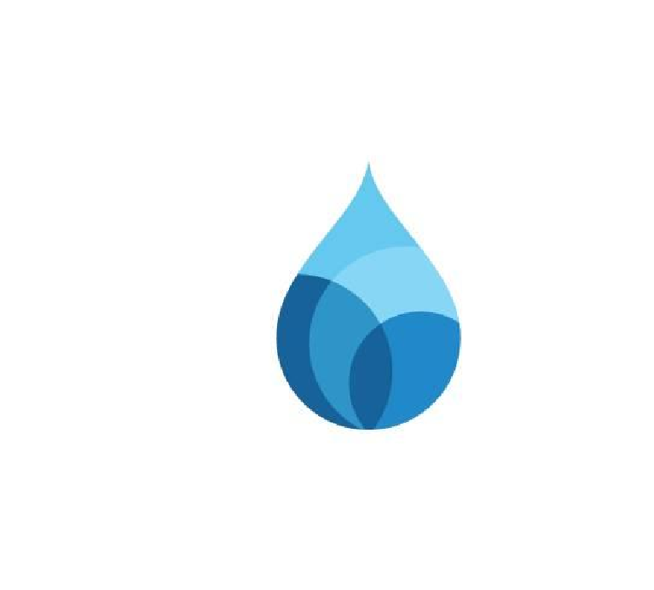
Somerset Domestic Waterworks District
3764 Highway 133 P.O. Box 549
Somerset, CO 81434
(970) 929-5211
Open Office Hours: Every Wednesday 10am-2pm

Join CPW to learn about living with bears. District Wildlife Manager David Gurzick will be joining us in the Somerset Community Center to discuss living in bear country, bear behavior, what to do in the case of a bear interaction, and ways that we can coexist with bears. This event will take place May 30th, 2026 at 6:00 PM at 3764 HWY 133, Somerset, CO 81434. David is happy to happy to answer any questions and is excited to meet you!

